FAKE NEWS

Definition: a story that is presented as being a genuine item of news but is in fact not true and is intended to deceive people.

Intro
Watch the video in class and answer the following questions:

‘How false news can spread’:
TedED Noah Tavlin, https://www.youtube.com/watch?v=cSKGa_7XJkg

1. “A _____________ can travel half way around the world while the __________ is putting on its
shoes.”
2. Who said this?
3. How was information gathered in previous decades?
4. What has created the ideal conditions for circular reporting?
5. What are 2 ways circular reporting works?
a)
b)
6. Give an example of circular reporting:
7. What is user-generated content?
8. What benefit has come from recent advances in communication technology?
9. What can help slow down a lie?

Exercise 1

a. Work with a partner. Discuss these questions:

• Have you ever believed a fake news story? What made it believable?
• What are the purposes for the creation of fake news?
• What can/should people do to avoid fake news?

b. You would like to find some facts about penguins. Look at the list of information sources. Rank the sources from 1–5 based on how much you would trust them (1 = most reliable, 5 = least reliable)

• a page about penguins on Wikipedia ______
• a reference book called ‘The Wildlife of Antarctica’, published in 1992 ______
• a fact page on a website called ‘welovepenguins.com’________
• a fact page on a website for a wildlife charity _______
• an online article with the headline ‘Top 10 AMAZING facts about penguins that you WON’T BELIEVE!’_______

Explain your answers to another pair. Justify your opinions.

EXERCISE 2

a. Work with a partner. Look at the words/phrases in the box.

• Explain the words/phrases you already know.

b. Match the words or phrases from the box with their correct definition. You may need to change the form of the word or phrase.

1. The headline needs to be more forceful so that it ___________ the readers _____________ .
2. What kind of ____________ material did you use to research your paper?
3. I really think you are _____________. I mean, there is no way you can be objective when the candidate is your best friend!
4. This medication may not be suitable for people with existing illnesses. ____________ , consult your doctor before using this product.
5. The ___________ that you felt the need to come all the way over here shows me that you must care a lot.
6. Sorry, I’m a Windows user. I’m not _______________ Macs. Could you help me understand what I’m doing wrong here?
7. They ___________ their interest in buying the house straight after they visited it.
8. The suspect ___________________ that he was at home when the crime took place.
9. I don’t really watch the news. I listen to the ____________________________ now and then, but I find most of the news these days depressing.

EXERCISE 3

a. Identifying fake news isn’t easy! The table below lists various tips to help you decide whether an online information source can be trusted. Match the tip title to its description.

• Think about the source • Is it a joke?
• Are you biased? • Check the author
• Ask the experts • Check the date
• Keep reading … • Supporting sources

1. Do you know the source? Have you used this source in the past? What is the mission or purpose of the website (e.g. to entertain, inform, promote, sell, etc)? Where was this source shared? Do you trust information that is shared on social media?
2. Sometimes articles begin with a headline that grabs the reader’s attention. Read on, because the headline may not tell the whole story.
3. Who wrote the article? Are you familiar with the writer? Are they even a real person?
4. If a story includes sources for its facts, click on the sources. Check the details – do the sources actually say what the story claims?
5. When was the article published? Is it up-to-date, or is it old news? Be careful – some sites will repost old stories but change the date to make them seem more recent.
6. Is the article actually serious? There are many sites which share fake stories that are meant to be funny.
7. What’s your opinion on the topic? People often trust information that confirms their own beliefs. We are also more likely to trust information shared by people (e.g. friends) that have similar beliefs to our own. A story might share ideas that support your own views, but that doesn’t mean they are true.
8. If in doubt, ask an expert. There are online fact checking sites that can help you decide if information is real or fake.

EXERCISE 4

a. Read the short article on penguins below. Work with a partner and create ten specific questions for the reader. The questions should help the reader notice that this text is fake.

Examples from paragraph 1:

‘The population of penguins in Antarctica is at its lowest since records began in 1921.’

• Did records on penguin populations really begin in 1921?

‘Some sources have reported an 80% decline in penguin numbers across the continent in the last 50 years.’

• Which sources?

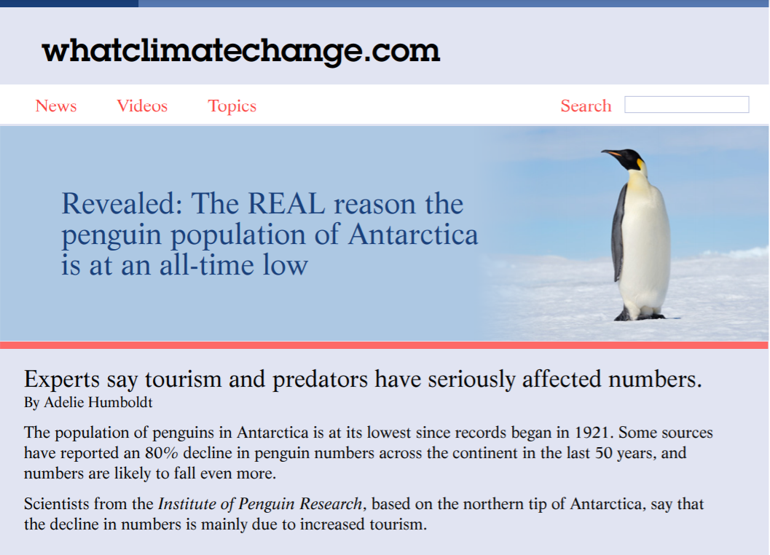

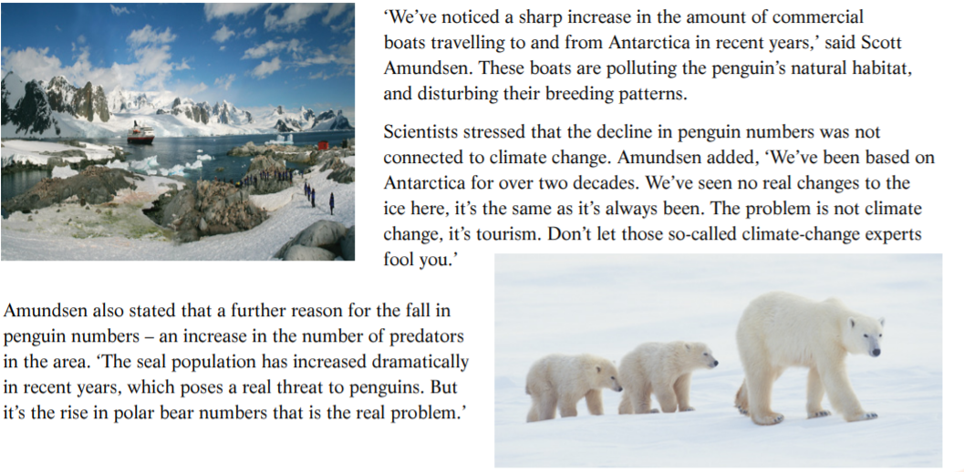

c. Discuss the questions with a partner.

• Which fake features of the text did you find it easy/difficult to identify?
• Do you often check supporting sources, author details or website missions when you read an online article? Why / Why not?
• Is there anything you’ve learnt from this activity that you can apply in real life?

EXERCISE 5

a. Further Fake News vocabulary:
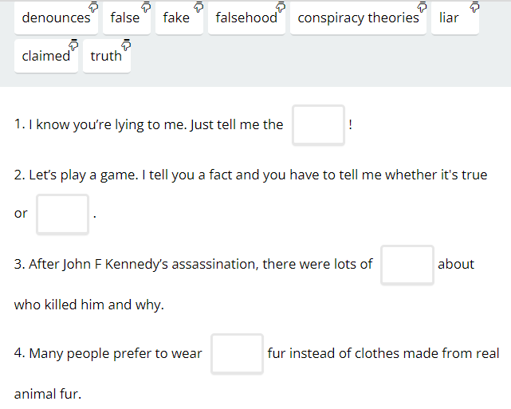

Answers:

1. ___________

2. ___________

3. ___________

4. ___________

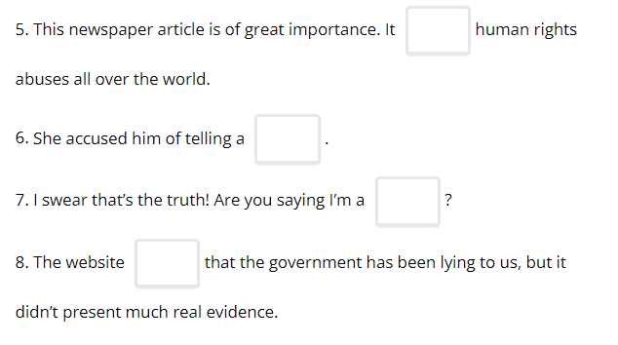
5. ___________

6. ___________

7. ___________

8. ___________

b. Now, find your own Fake News article:

Analyse the article using the tips from this lesson. Share your findings with a partner & the class.

FINAL DISCUSSION​

- How do you decide where you get your news from?
- How do you usually get your news? (TV, podcasts, social media, newspaper/newspaper websites etc.)
- Do you think the Fake News problem is likely to go away soon? Why/why not?

